# Cart Summary

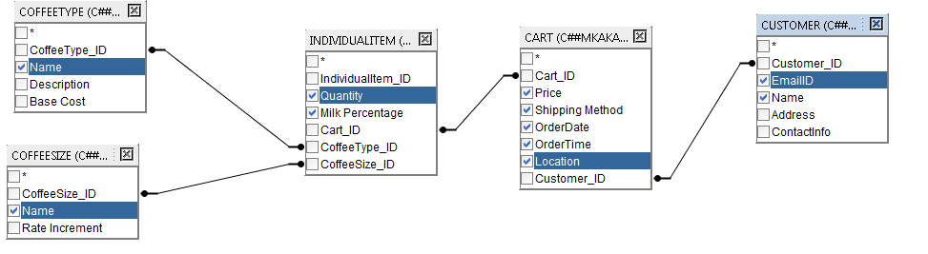

SELECT

cart."Cart_ID",

coffeetype."Name" AS "Coffee_Name",

coffeesize."Name" AS "Coffee_Size",

individualitem."Milk Percentage",

individualitem."Quantity",

cart."Price",

cart."Shipping Method",

cart."OrderDate",

cart."OrderTime",

cart."Location",

customer."Name" AS "Customer",

customer."EmailID"

FROM

individualitem

INNER JOIN cart ON cart."Cart_ID" = individualitem."Cart_ID"

INNER JOIN coffeetype ON coffeetype."CoffeeType_ID" = individualitem."CoffeeType_ID"

INNER JOIN coffeesize ON individualitem."CoffeeSize_ID" = coffeesize."CoffeeSize_ID"

INNER JOIN customer ON cart."Customer_ID" = customer."Customer_ID"

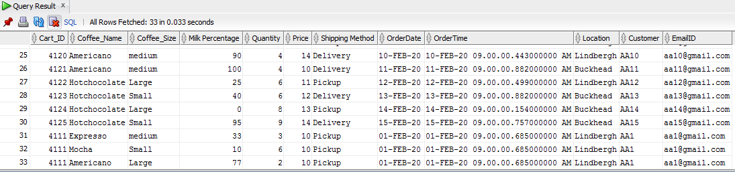

# Most Ordered Coffee Size

# 

SELECT

coffeesize."Name",

COUNT(coffeesize."Name") AS "Count_Name"

FROM

individualitem

INNER JOIN coffeesize ON individualitem."CoffeeSize_ID" = coffeesize."CoffeeSize_ID"

GROUP BY

coffeesize."Name"

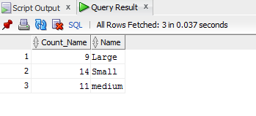

# Which Coupons were used by Customer ‘AA1’?

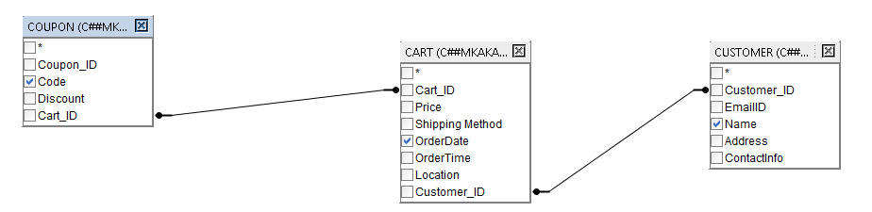

SELECT

.coupon."Code",

.customer."Name",

.cart."OrderDate"

FROM

.customer

INNER JOIN .cart ON .customer."Customer_ID" = .cart."Customer_ID"

INNER JOIN .coupon ON .coupon."Cart_ID" = .cart."Cart_ID"

WHERE

.customer."Name" = 'AA1'

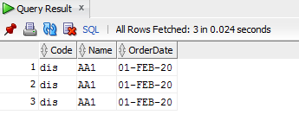

# Compare the number of coffee sizes ordered in the first week of February

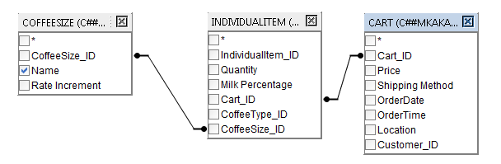

SELECT

.coffeesize."Name",

COUNT(.individualitem."Quantity") AS "Count_Quantity"

FROM

.coffeesize

INNER JOIN .individualitem ON .coffeesize."CoffeeSize_ID" = .individualitem."CoffeeSize_ID"

INNER JOIN .cart ON .cart."Cart_ID" = .individualitem."Cart_ID"

WHERE

.cart."OrderDate" < '07-Feb-20'

GROUP BY

.coffeesize."Name"

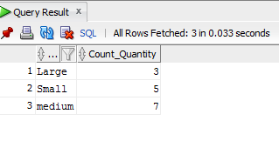

# 5. Coffee Types ordered in Lindbergh

# 

SELECT

cart."Location" AS "Location",

coffeetype."Name" AS "Coffee Type",

COUNT(coffeetype."Name") AS "Count"

FROM

individualitem

INNER JOIN cart ON cart."Cart_ID" = individualitem."Cart_ID"

INNER JOIN coffeetype ON coffeetype."CoffeeType_ID" = individualitem."CoffeeType_ID"

WHERE

cart."Location" = 'Lindbergh'

GROUP BY

cart."Location",

coffeetype."Name"

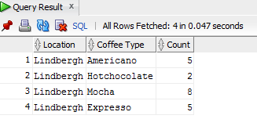

# 6. Coupons applies vs Price of Cart

# 

SELECT

coupon."Cart_ID",

cart."Price",

coupon."Code",

coupon."Discount"

FROM

cart

INNER JOIN coupon ON coupon."Cart_ID" = cart."Cart_ID"

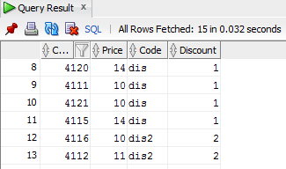

# 7. Get Data from Order History for suggesting a recommendation to a given customer while they are shopping on the site

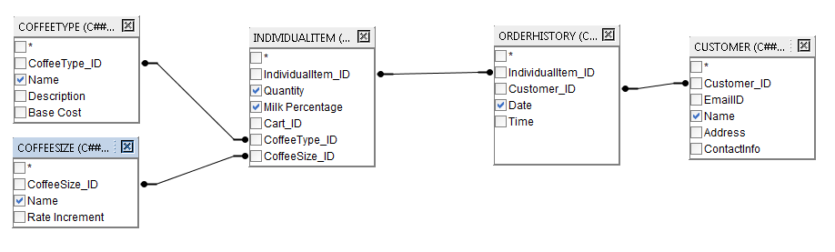

SELECT * FROM (

SELECT

.customer."Name",

.coffeetype."Name" AS "Coffee Type",

.coffeesize."Name" AS "Coffee Size",

.individualitem."Milk Percentage",

.individualitem."Quantity",

.orderhistory."Date"

FROM

.orderhistory

INNER JOIN .individualitem ON .orderhistory."IndividualItem_ID" = .individualitem

."IndividualItem_ID"

INNER JOIN .coffeesize ON .coffeesize."CoffeeSize_ID" = .individualitem."CoffeeSize_ID"

INNER JOIN .coffeetype ON .coffeetype."CoffeeType_ID" = .individualitem."CoffeeType_ID"

INNER JOIN .customer ON .customer."Customer_ID" = .orderhistory."Customer_ID"

WHERE

.customer."Name" = 'AA1'

ORDER BY

.orderhistory."Date" DESC,

.individualitem."Quantity" DESC

) WHERE ROWNUM = 1

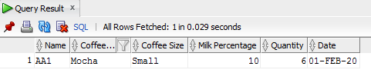

# 8. Compare the number of orders and order prices coming from each location

# 

SELECT

.cart."Location",

COUNT(.cart."Location") AS "Count_Orders",

SUM(.cart."Price") AS "Sum_Price"

FROM

.cart

GROUP BY

.cart."Location"

# 

# 9. Most Frequent Customer

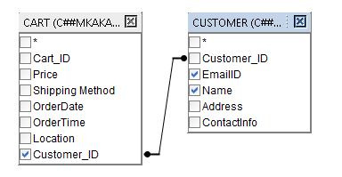

SELECT

COUNT(cart."Customer_ID") AS "Count_Customer_ID",

customer."Name",

customer."EmailID",

cart."Customer_ID"

FROM

cart

INNER JOIN customer ON customer."Customer_ID" = cart."Customer_ID"

GROUP BY

customer."Name",

customer."EmailID",

cart."Customer_ID"

ORDER BY

"Count_Customer_ID" DESC

FETCH NEXT 1 ROWS ONLY

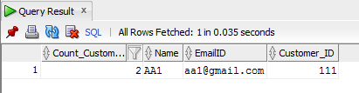

# 10. Top 5 Customer name and emails with costliest orders

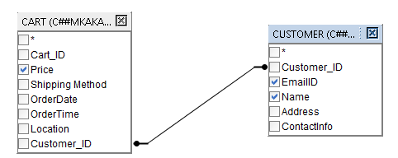

SELECT

customer."Name",

customer."EmailID”

cart."Price"

FROM

cart

INNER JOIN customer ON cart."Customer_ID" = customer."Customer_ID"

WHERE

ROWNUM <= 1

ORDER BY

cart."Price" DESC

